sudo yum update -y

login into Amazon Linux and update package manager

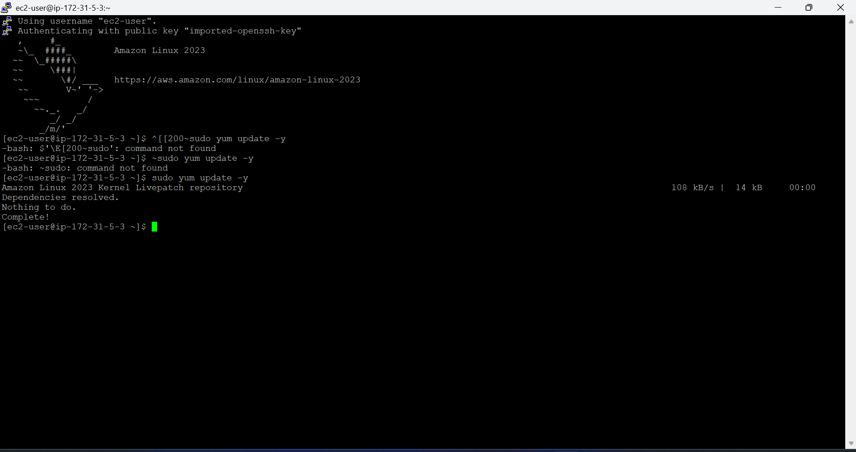

sudo yum install -y docker

install docker

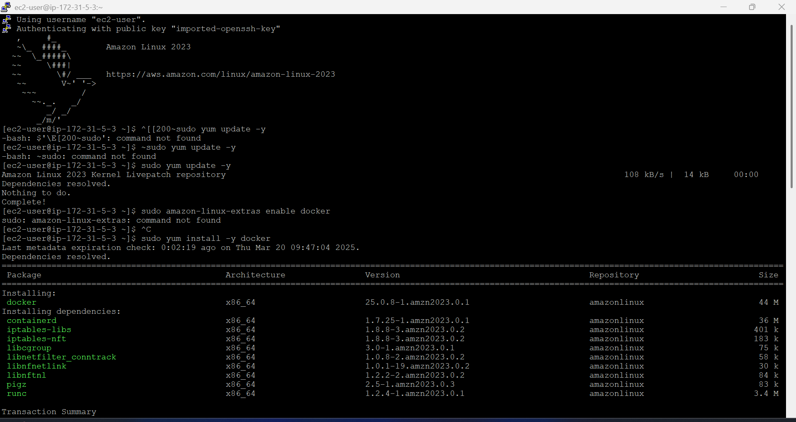

sudo systemctl start docker

start docker service

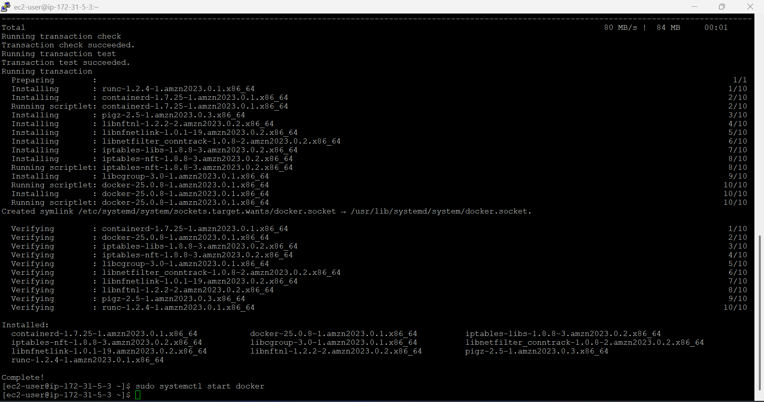

sudo systemctl enable Docker

enable Docker service

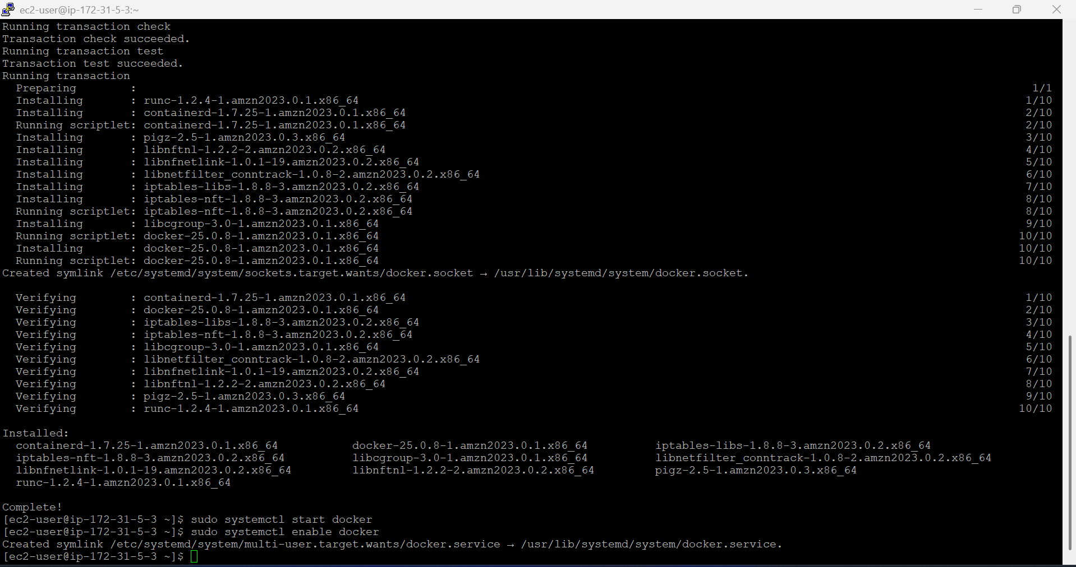

docker –version

Verify Docker installation

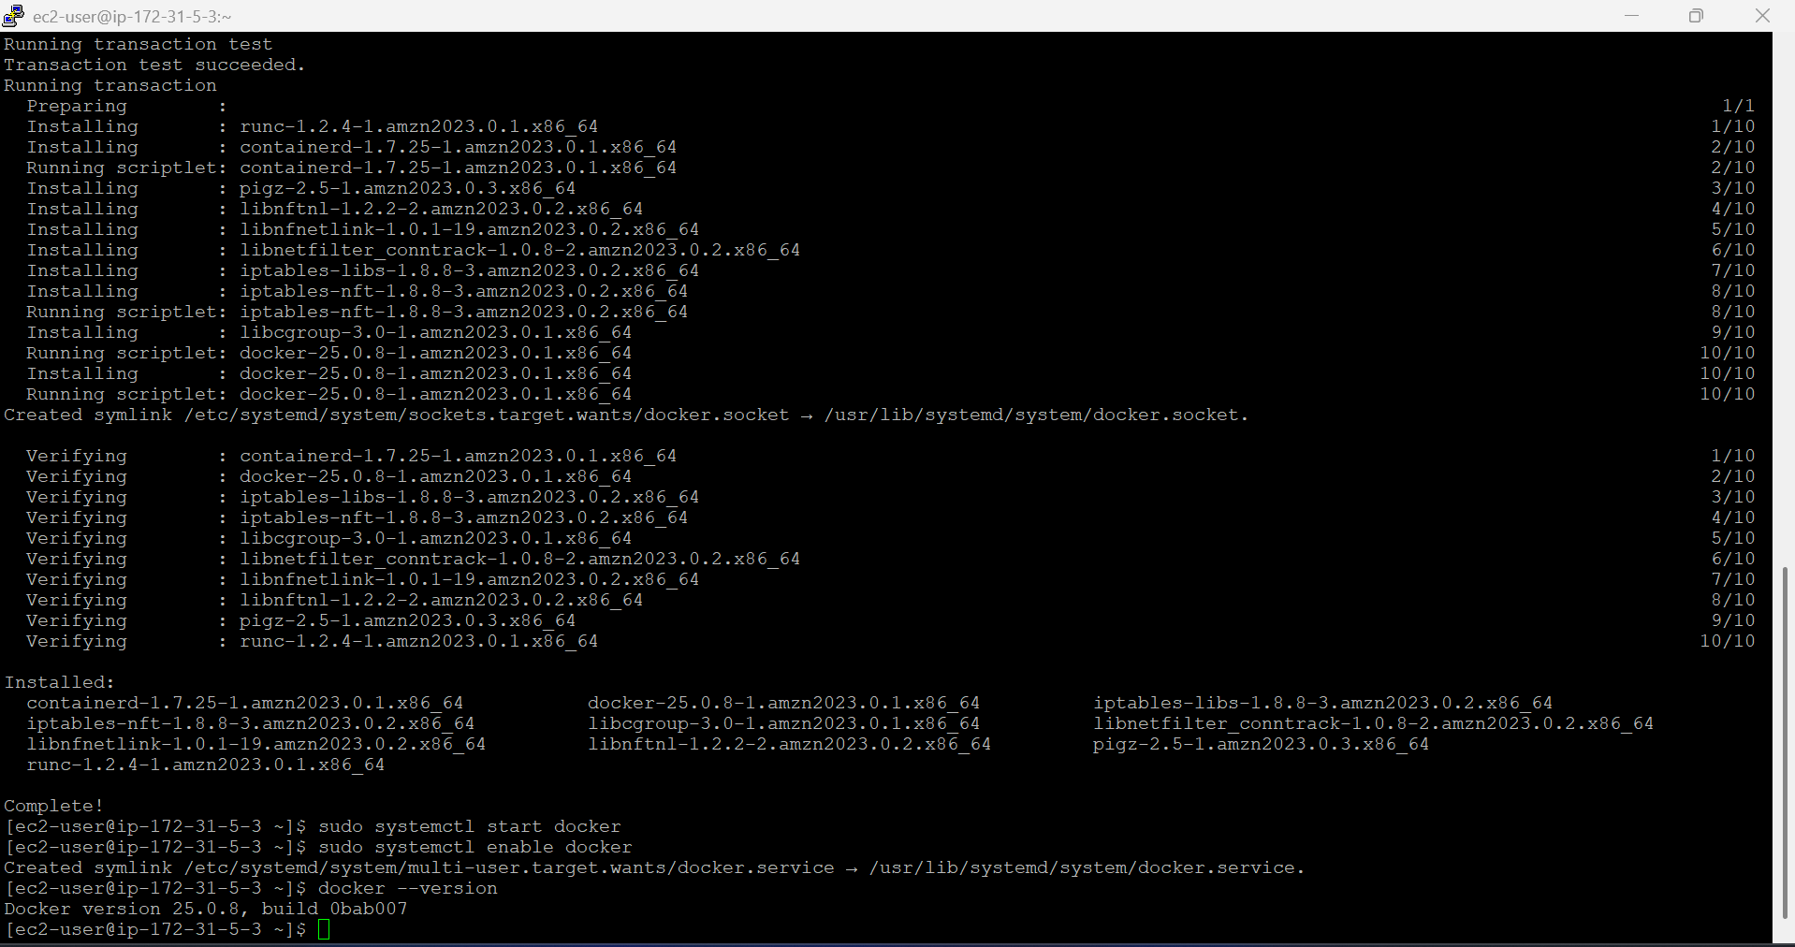

sudo usermod -aG docker ec2-user

By default, Docker commands require sudo. To avoid this, add the ec2-user to the docker group:

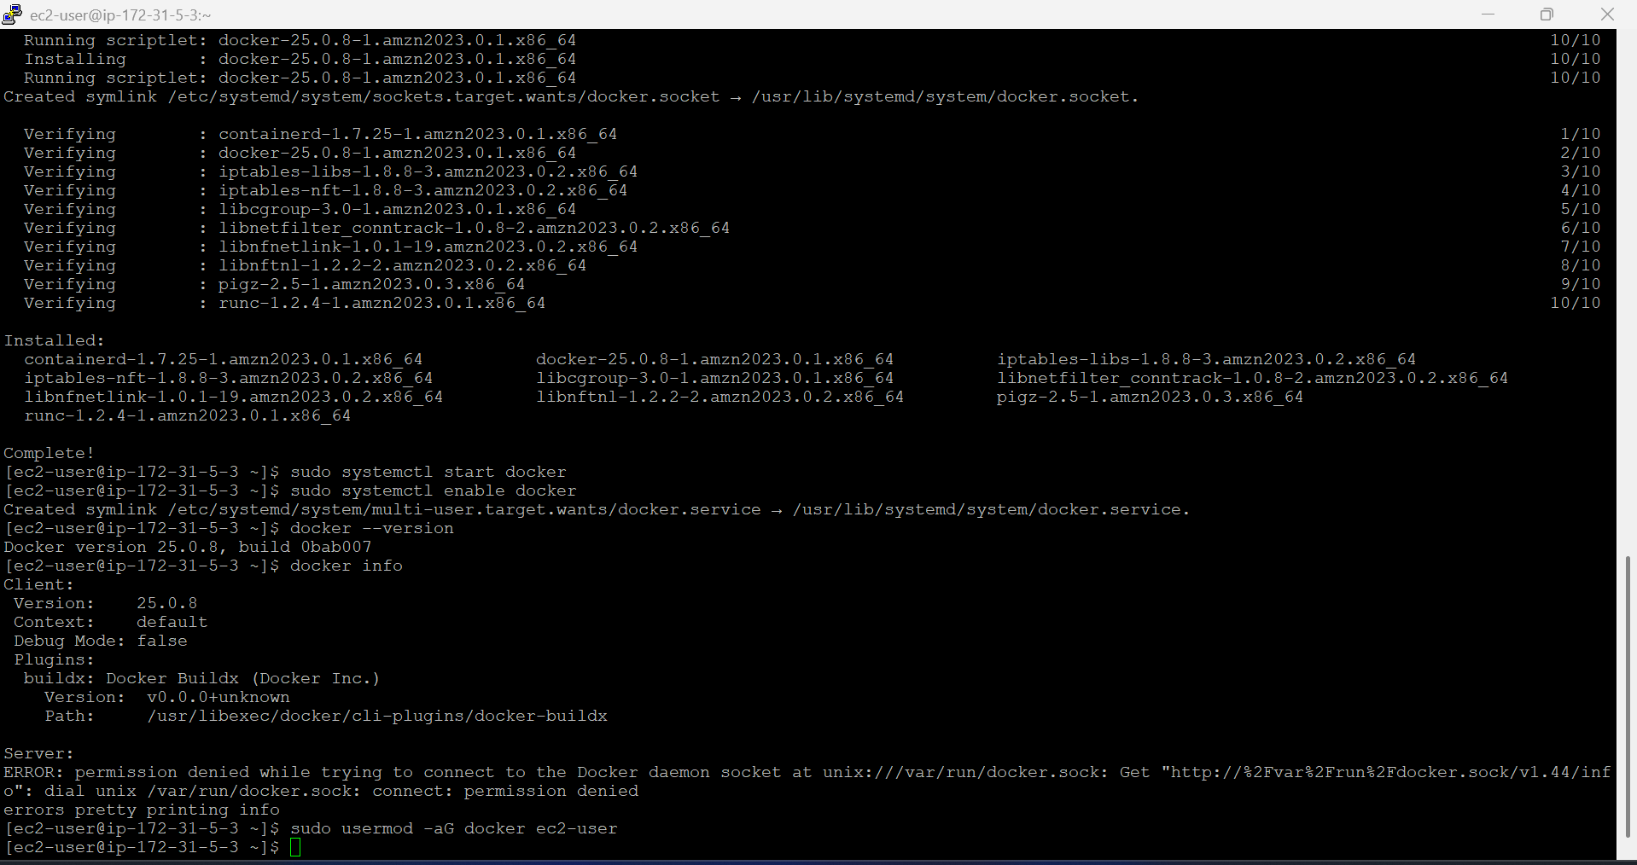

Log out and log back in for the changes to take effect:

Run the following command to verify the installation:

docker info

This should output details about Docker, including storage drivers, container runtimes, and networking configurations.

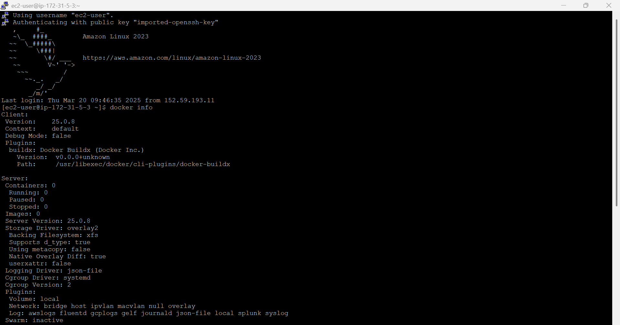

To ensure Docker is working, run the **Hello World** container:

docker run hello-world

